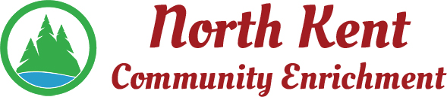
204 E. Muskegon Cedar Springs, MI 49319
616-696-7320 www.myNKCE.com
Agenda for Regular Meeting of Monday Nov 1, 2021 @ 6:00 PM IN PERSON

- Call to order

- Approval of agenda
- Consent Agenda
  - Approval of October 2021 Minutes
  - Approval of October Financial Statements

- Information and Discussion Items
  - Daddy daughter Dance - Feb 5th
  - Mother Son Nerf war – March 5th
  - Chicago Bus trip – November 13
  - Fall Events
  - Financial report

- Action Items

  - Confirm Next Meeting December 6, 2021
- Adjourn

